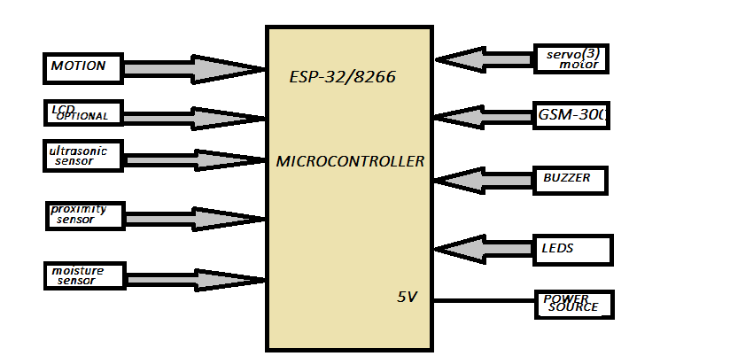**SMART I-WASTE MANGEMENT SYSTEM**

*Objective*:1**.**To create or make a user friendly smart waste management system that will simplify the recycling process for the public or make it more streamline.

1. To develop an a model that will direct the waste(dry,wet,metal…) to the proper bins.

*BLOCK DIAGRAM:*



**Components that will be using:**

1. proximity sensor
2. Moisture sensor
3. Ultrasonic sensor(3)
4. Motion sensor
5. GSM-300
6. Sound Buzzer
7. Servo motor
8. LCD display (optional)
9. Micro-controller Esp-32or 8266
10. Power supply 5 volt
11. Outer body structure